**Objective:**

**Theory:**

Multiplexers: A multiplexer is a combinational circuit that selects binary information from one of many input lines and directs it to a single output line. The selection of a particular input line is controlled by a set of selection lines. Normally, there are 2n input lines and n selection lines whose bit combinations determine which input is selected. A block diagram and truth table for a 4:1 Multiplexer (4 inputs and 1 output) is given below

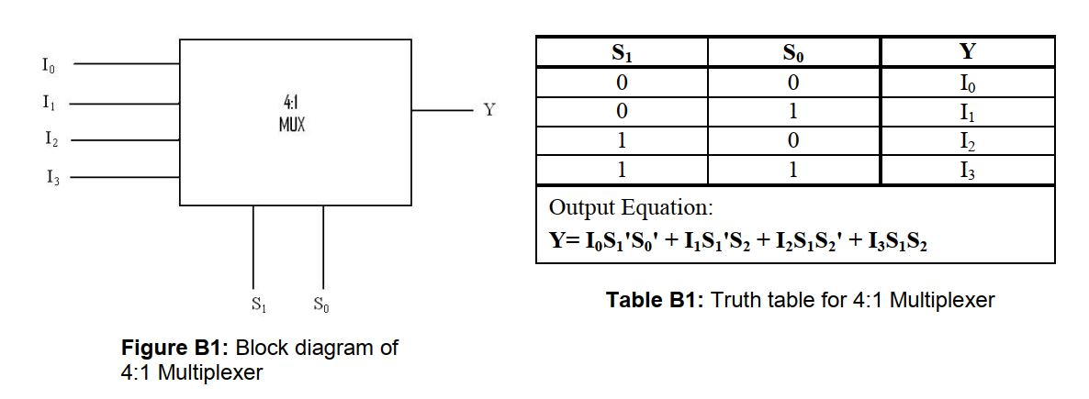

**D flip-flop:** The D flip-flop captures the value of the D-input at a definite portion of the clock cycle (such as the rising edge of the clock). That captured value becomes the Q output. At other times, the output Q does not change.

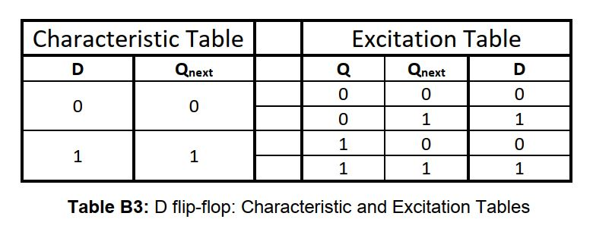

**Apparatus:**

* 16:1 Mux IC 74150
* BCD 7 segment
* 3 input AND gate IC 4073
* 3 input OR gate IC 4075
* 2 input OR gate IC 7432
* NOT gate IC 7404 – 1
* Resistor 10k
* Timer IC 555
* Capacitor 22uF 16volt
* Jumper wire
* Battery
* LM 2596 DC to DC (Bug)
* D flip-flop IC 7474

**State diagram:**

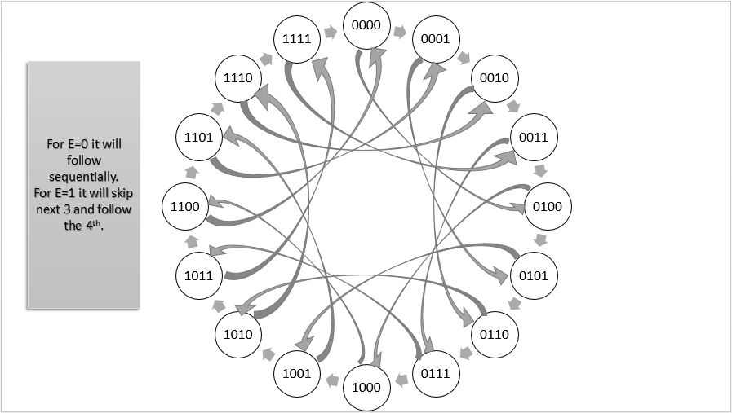

**Truth table:**

**Combinational Part**

|  |  |  |  |  |  |  |  |  |  |  |  |  |  |
| --- | --- | --- | --- | --- | --- | --- | --- | --- | --- | --- | --- | --- | --- |
|  |  | A | B | C | D | a | b | c | d | e | f | g | dot |
| 0 | J | 0 | 0 | 0 | 0 | 1 | 1 | 1 | 1 | 1 | 0 | 0 | 1 |
| 1 | C | 0 | 0 | 0 | 1 | 1 | 0 | 0 | 1 | 1 | 1 | 0 | 1 |
| 2 | S | 0 | 0 | 1 | 0 | 1 | 0 | 1 | 1 | 0 | 1 | 1 | 1 |
| 3 | E | 0 | 0 | 1 | 1 | 1 | 0 | 0 | 1 | 1 | 1 | 1 | 1 |
| 4 | 2 | 0 | 1 | 0 | 0 | 1 | 1 | 0 | 1 | 1 | 0 | 1 | 1 |
| 5 | 3 | 0 | 1 | 0 | 1 | 1 | 1 | 1 | 1 | 0 | 0 | 1 | 1 |
| 6 | 1 | 0 | 1 | 1 | 0 | 0 | 1 | 1 | 0 | 0 | 0 | 0 | 1 |
| 7 | . | 0 | 1 | 1 | 1 | 0 | 0 | 0 | 0 | 0 | 0 | 0 | 1 |
| 8 | 7 | 1 | 0 | 0 | 0 | 1 | 1 | 1 | 0 | 0 | 0 | 0 | 1 |
| 9 | G | 1 | 0 | 0 | 1 | 1 | 0 | 1 | 1 | 1 | 1 | 0 | 1 |
| 10 | 0 | 1 | 0 | 1 | 0 | 1 | 1 | 1 | 1 | 1 | 1 | 0 | 1 |
| 11 | 2 | 1 | 0 | 1 | 1 | 1 | 1 | 0 | 1 | 1 | 0 | 1 | 1 |
| 12 | P | 1 | 1 | 0 | 0 | 1 | 1 | 0 | 0 | 1 | 1 | 1 | 1 |
| 13 | r | 1 | 1 | 0 | 1 | 0 | 0 | 1 | 0 | 1 | 0 | 1 | 1 |
| 14 | 0 | 1 | 1 | 1 | 0 | 0 | 0 | 1 | 1 | 1 | 0 | 1 | 1 |
| 15 | x | 1 | 1 | 1 | 1 | x | x | x | x | x | x | x | x |

**Sequential part**

|  |  |  |  |  |  |  |  |  |  |  |  |  |  |  |  |  |  |  |  |  |  |  |  |  |  |
| --- | --- | --- | --- | --- | --- | --- | --- | --- | --- | --- | --- | --- | --- | --- | --- | --- | --- | --- | --- | --- | --- | --- | --- | --- | --- |
|  | E | A | B | C | D | A(n) | B(n) | C(n) | D(n) | J-A | K-A | J-B | K-B | J-C | K-C | J-D | K-D | D-A | D-B | D-C | D-D | T-A | T-B | T-C | T-D |
| 0 | 0 | 0 | 0 | 0 | 0 | 0 | 0 | 0 | 1 | 0 | x | 0 | x | 0 | x | 1 | x | 0 | 0 | 0 | 1 | 0 | 0 | 0 | 1 |
| 1 | 0 | 0 | 0 | 0 | 1 | 0 | 0 | 1 | 0 | 0 | x | 0 | x | 1 | x | x | 1 | 0 | 0 | 1 | 0 | 0 | 0 | 1 | 1 |
| 2 | 0 | 0 | 0 | 1 | 0 | 0 | 0 | 1 | 1 | 0 | x | 0 | x | x | 0 | 1 | x | 0 | 0 | 1 | 1 | 0 | 0 | 0 | 1 |
| 3 | 0 | 0 | 0 | 1 | 1 | 0 | 1 | 0 | 0 | 0 | x | 1 | x | x | 1 | x | 1 | 0 | 1 | 0 | 0 | 0 | 1 | 1 | 1 |
| 4 | 0 | 0 | 1 | 0 | 0 | 0 | 1 | 0 | 1 | 0 | x | x | 0 | 0 | x | 1 | x | 0 | 1 | 0 | 1 | 0 | 0 | 0 | 1 |
| 5 | 0 | 0 | 1 | 0 | 1 | 0 | 1 | 1 | 0 | 0 | x | x | 0 | 1 | x | x | 1 | 0 | 1 | 1 | 0 | 0 | 0 | 1 | 1 |
| 6 | 0 | 0 | 1 | 1 | 0 | 0 | 1 | 1 | 1 | 0 | x | x | 0 | x | 0 | 1 | x | 0 | 1 | 1 | 1 | 0 | 0 | 0 | 1 |
| 7 | 0 | 0 | 1 | 1 | 1 | 1 | 0 | 0 | 0 | 1 | x | x | 1 | x | 1 | x | 1 | 1 | 0 | 0 | 0 | 1 | 0 | 1 | 1 |
| 8 | 0 | 1 | 0 | 0 | 0 | 1 | 0 | 0 | 1 | x | 0 | 0 | x | 0 | x | 1 | x | 1 | 0 | 0 | 1 | 0 | 0 | 0 | 1 |
| 9 | 0 | 1 | 0 | 0 | 1 | 1 | 0 | 1 | 0 | x | 0 | 0 | x | 1 | x | x | 1 | 1 | 0 | 1 | 0 | 0 | 0 | 1 | 1 |
| 10 | 0 | 1 | 0 | 1 | 0 | 1 | 0 | 1 | 1 | x | 0 | 0 | x | x | 0 | 1 | x | 1 | 0 | 1 | 1 | 0 | 1 | 0 | 1 |
| 11 | 0 | 1 | 0 | 1 | 1 | 1 | 1 | 0 | 0 | x | 0 | 1 | x | x | 1 | x | 1 | 1 | 1 | 0 | 0 | 0 | 0 | 1 | 1 |
| 12 | 0 | 1 | 1 | 0 | 0 | 1 | 1 | 0 | 1 | x | 0 | x | 0 | 0 | x | 1 | x | 1 | 1 | 0 | 1 | 0 | 0 | 0 | 1 |
| 13 | 0 | 1 | 1 | 0 | 1 | 1 | 1 | 1 | 0 | x | 0 | x | 0 | 1 | x | x | 1 | 1 | 1 | 1 | 0 | 0 | 0 | 1 | 1 |
| 14 | 0 | 1 | 1 | 1 | 0 | 0 | 0 | 0 | 0 | x | 1 | x | 1 | x | 1 | 0 | x | 0 | 0 | 0 | 0 | 1 | 1 | 1 | 0 |
| 15 | 0 | 1 | 1 | 1 | 1 | x | x | x | x | x | x | x | x | x | x | x | x | x | x | x | x | x | x | x | x |
| 16 | 1 | 0 | 0 | 0 | 0 | 0 | 1 | 0 | 0 | 0 | x | 1 | x | 0 | x | 0 | x | 0 | 1 | 0 | 0 | 0 | 1 | 0 | 0 |
| 17 | 1 | 0 | 0 | 0 | 1 | 0 | 1 | 0 | 1 | 0 | x | 1 | x | 0 | x | x | 0 | 0 | 1 | 0 | 1 | 0 | 1 | 0 | 0 |
| 18 | 1 | 0 | 0 | 1 | 0 | 0 | 1 | 1 | 0 | 0 | x | 1 | x | x | 0 | 0 | x | 0 | 1 | 1 | 0 | 0 | 1 | 0 | 0 |
| 19 | 1 | 0 | 0 | 1 | 1 | 0 | 1 | 1 | 1 | 0 | x | 1 | x | x | 0 | x | 0 | 0 | 1 | 1 | 1 | 0 | 1 | 0 | 0 |
| 20 | 1 | 0 | 1 | 0 | 0 | 1 | 0 | 0 | 0 | 1 | x | x | 1 | 0 | x | 0 | x | 1 | 0 | 0 | 0 | 1 | 1 | 0 | 0 |
| 21 | 1 | 0 | 1 | 0 | 1 | 1 | 0 | 0 | 1 | 1 | x | x | 1 | 0 | x | x | 0 | 1 | 0 | 0 | 1 | 1 | 1 | 0 | 0 |
| 22 | 1 | 0 | 1 | 1 | 0 | 1 | 0 | 1 | 0 | 1 | x | x | 1 | x | 0 | 0 | x | 1 | 0 | 1 | 0 | 1 | 1 | 0 | 0 |
| 23 | 1 | 0 | 1 | 1 | 1 | 1 | 0 | 1 | 1 | 1 | x | x | 1 | x | 0 | x | 0 | 1 | 0 | 1 | 1 | 1 | 1 | 0 | 0 |
| 24 | 1 | 1 | 0 | 0 | 0 | 1 | 1 | 0 | 0 | x | 0 | 1 | x | 0 | x | 0 | x | 1 | 1 | 0 | 0 | 0 | 1 | 0 | 0 |
| 25 | 1 | 1 | 0 | 0 | 1 | 1 | 1 | 0 | 1 | x | 0 | 1 | x | 0 | x | x | 0 | 1 | 1 | 0 | 1 | 0 | 1 | 0 | 0 |
| 26 | 1 | 1 | 0 | 1 | 0 | 1 | 1 | 1 | 0 | x | 0 | 1 | x | x | 0 | 0 | x | 1 | 1 | 1 | 0 | 0 | 1 | 0 | 0 |
| 27 | 1 | 1 | 0 | 1 | 1 | 0 | 0 | 0 | 0 | x | 1 | x | 1 | x | 1 | x | 1 | 0 | 0 | 0 | 0 | 1 | 0 | 1 | 1 |
| 28 | 1 | 1 | 1 | 0 | 0 | 0 | 0 | 0 | 1 | x | 1 | x | 1 | 0 | x | 1 | x | 0 | 0 | 0 | 1 | 1 | 1 | 0 | 1 |
| 29 | 1 | 1 | 1 | 0 | 1 | 0 | 0 | 1 | 0 | x | 1 | x | 1 | 1 | x | x | 1 | 0 | 0 | 1 | 0 | 1 | 1 | 1 | 1 |
| 30 | 1 | 1 | 1 | 1 | 0 | 0 | 0 | 1 | 1 | x | 1 | x | 1 | x | 0 | 1 | x | 0 | 0 | 1 | 1 | 1 | 1 | 0 | 1 |
| 31 | 1 | 1 | 1 | 1 | 1 | x | x | x | x | x | x | x | x | x | x | x | x | x | x | x | x | x | x | x | x |

**Logisim:**

**Budget/cost estimation:**

**Project Photos:**

**Discussion:**